

Rating Prediction Project

Submitted by:

ROHIT KATTEWAR

ACKNOWLEDGEMENT

I would like to thank and express my sincere gratitude to Flip Robo Technologies for giving me the opportunity to work on this project named ‘Ratings Prediction’ using Machine Learning algorithms and NLTK suite.

Primarily, I would like to thank to the author of the paper titled: “Review-Based Rating Prediction” for providing me with invaluable knowledge and insights into the importance of contextual information of user sentiments in determining the rating of products, the role of Natural Language Processing tools and techniques in identifying the user sentiments towards various products based on their reviews and ratings and in helping build models to predict user ratings based on the input reviews.

Finally, I will thank my mentors, under whose guidance I learned a lot about Machine Learning, Natural Language Processing and much more.

INTRODUCTION

* **Business Problem Framing**

A website has a forum for writing technical reviews of products and consists of repository of reviews for technical products. Now they are adding a new feature to their website i.e. The reviewer will have to add stars(rating) as well with the review.

The rating is out 5 stars and it only has 5 options available 1 star, 2 stars, 3 stars, 4 stars, 5 stars. Now they want to predict ratings for the reviews which were written in the past and they don’t have a rating. An application to predict the rating by seeing the review is required to be built.

Therefore, a predictive model to accurately predict a user’s rating based on input review is required to be made.

* **Conceptual Background of the Domain Problem**

Predictive modelling, Classification algorithms are some of the machine learning techniques used along with the various libraries of the NLTK suite for Classification of comments.

Using NLTK tools, the frequencies of malignant words occurring in textual data were estimated and given appropriate weightage, whilst filtering out words, and other noise which do not have any impact on the semantics of the comments and reducing the words to their base lemmas for efficient processing and accurate classification of the comments.

* **Review of the Literature**

The given dataset is a part of the research paper named “Review Based Rating Prediction” by Tal Hadad. It was reviewed and studied to gain insights into the importance of contextual information of user sentiments in determining the rating of products, the role of natural language processing tools and techniques to identify the user sentiments towards the various product based on their reviews and ratings. The Contextual information about a user’s opinion of a product can be explicit or implicit and can be inferred in different ways such as user score ratings and textual reviews.

* **Motivation for the Problem Undertaken**

The motivation behind this is to understand the user experience and sentiments towards the product. The sentiment of a user towards a product is reflected in their rating score and their review of the product. This shows how the product is perceived by the consumers and in turn gives an idea about the acceptance of the product by the consumers. This study will help us understand the product’s worth and acceptance by the customer.

ANALYTICAL PROBLEM FRAMING

* **Mathematical/Analytical Modeling of the Problem:**

The process of building a predictive model, in this case, different classification analysis techniques were used to build such model. The model will help us understand the relationship between the user reviews of the particular product and the actual product offerings. To predict the ratings for the product, different models such as Logistic regression, Random Forest Classifier Boost Classifier, Extreme Gradient Boost Classifier, Multinomial Naïve Bayes Classifier, Complement Naïve Bayes Classifier and Passive Aggressive Classifier were used.

* **Data Sources and their Formats:**

The dataset is created by using Web Scrapping technique to scrape the user reviews and ratings for the different set of products from <https://www.amazon.in/> e-commerce website.

* **Dataset Description:**

The dataset is created by using web scrapping technique which involve the Selenium which is an automation software to scrape the product reviews and ratings. I, firstly, scrapped 17400 reviews and ratings of the multiple products from Amazon.in then I scrapped some more products reviews and ratings for the different set of products than the previous ones. I combined the both the data frames into one and made the sole file for the reviews and ratings for the products.

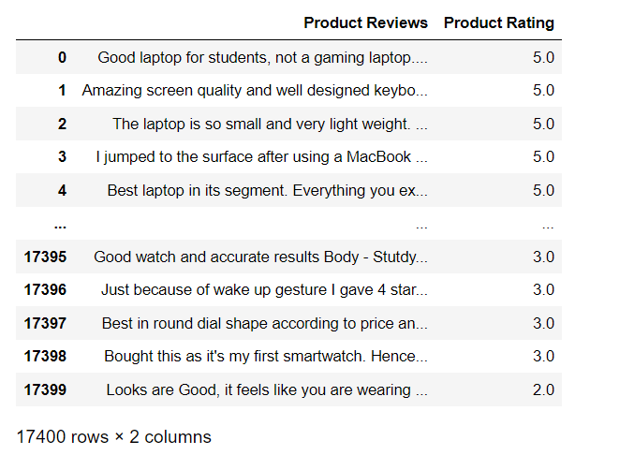

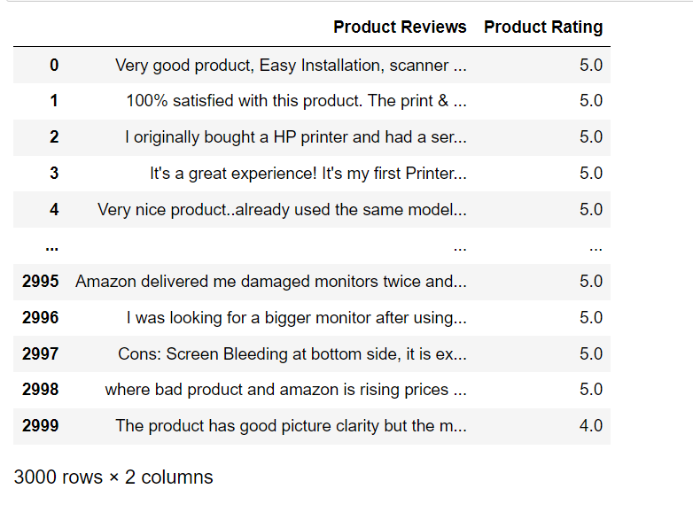

We combined the above two data frames and merged them.

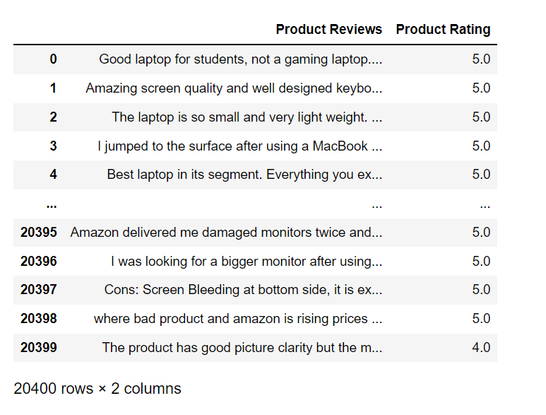

The image above shows the combined data frame which has 20400 the reviews and ratings of the various products.

The Columns are:

1. **Product Reviews**: User review of the Product
2. **Product Rating**: User rating of the Product

* **Data Pre-processing Done:**

1. Rows with null values were removed.
2. Columns: Unnamed: 0(just a series of numbers) was dropped since it doesn't contribute to building a good model for predicting the target variable values.
3. The train and test dataset contents were then converted into lowercase.
4. Punctuations, unnecessary characters etc were removed, currency symbols, phone numbers, web URLs, email addresses etc were replaced with single words.
5. Tokens that contributed nothing to semantics of the messages were removed as Stop words. Finally retained tokens were lemmatized using WordNetLemmatizer().
6. The string lengths of original comments and the cleaned comments were then compared.

* **Data Inputs- Logic- Output Relationships:**

The comment tokens so vectorised using TF-IDF Vectorizer are input and the corresponding rating is predicted based on their context as output by classification models.

* **Exploratory Data Analysis:**

**Visualizations:** Bar plots, Count plots, Word Clouds were used to visualise the data of all the columns and their relationships with Target variable.

Word Clouds of the most frequent words used in reviews corresponding to the various Rating Scores:

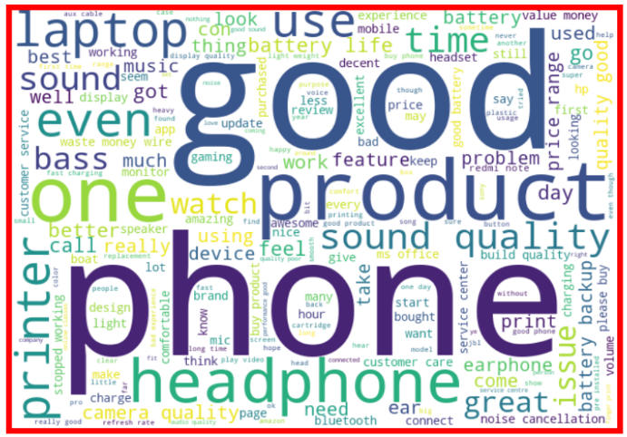  
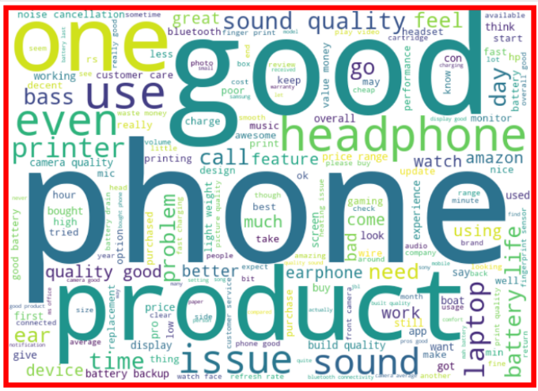

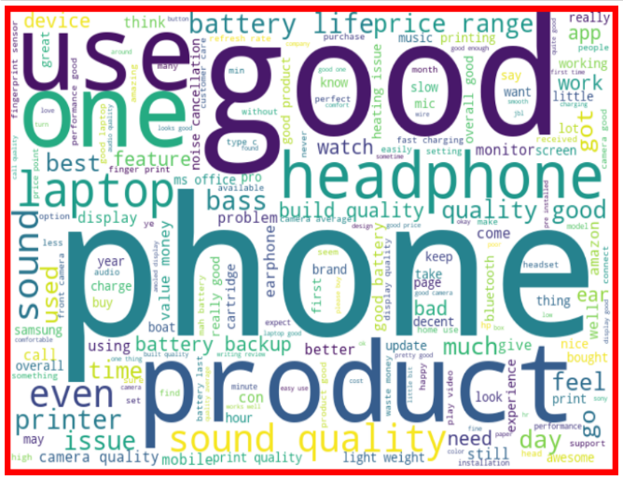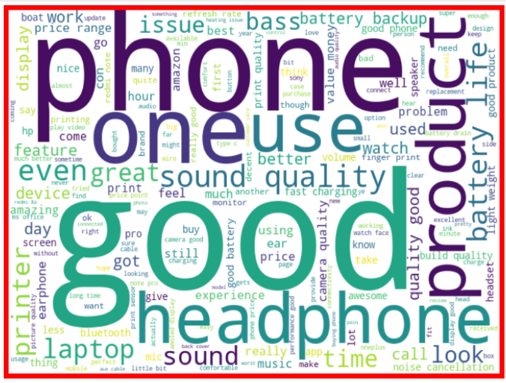

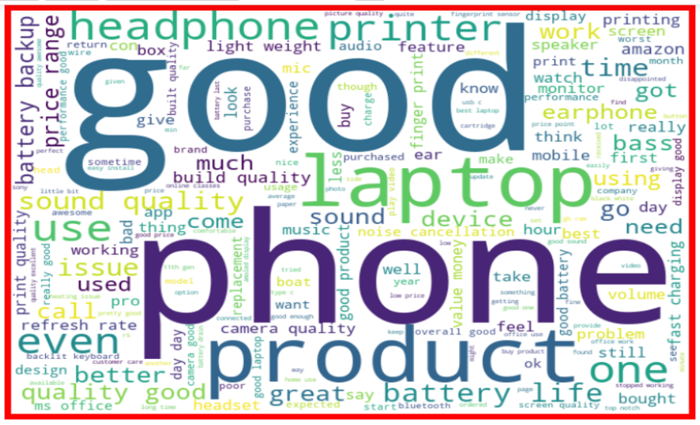

From the graphs above the following observations are made:

1. Reviews corresponding to 5.0 rating frequently carry words like: ‘great’,’best’,’perfect’,’better,’good’ etc indicating very high customer satisfaction and high-quality product.
2. Reviews corresponding to 4.0 rating frequently carry words like: ‘good’,’better’,’nice’,’value money’,’look’, ‘quality’,’awesome’ etc indicating high customer satisfaction and good quality product.
3. Reviews corresponding to 3.0 rating frequently carry words like: ‘good’,’well’,’sound,’bad quality’,’issue’ etc indicating customer dissatisfaction and average to below average product quality.
4. Reviews corresponding to 2.0 rating frequently carry words like: ‘problem’, ‘replacement,’stopped working’,’worst experience’,’quality’ etc indicating high customer dissatisfaction and below average product quality.
5. Reviews corresponding to 1.0 rating frequently carry words like: ‘issue sound’,’working’,’cheap’,’return’,’issue’,’waste money’,’poor quality’,’customer care’,’bad’,’used’,’worst’, ‘poor build quality’ etc indicate very high customer dissatisfaction and poor quality product.

* **Model Building:**

Following are the model algorithms that were used:

1. Logistic Regression: It is a classification algorithm used to find the probability of event success and event failure. It is used when the dependent variable is binary(0/1, True/False, Yes/No) in nature. It supports categorizing data into discrete classes by studying the relationship from a given set of labelled data. It learns a linear relationship from the given dataset and then introduces a nonlinearity in the form of the Sigmoid function. It not only provides a measure of how appropriate a predictor(coefficient size)is, but also its direction of association (positive or negative).
2. Multinomial Naïve Bayes Classifier: Multinomial Naive Bayes algorithm is a probabilistic learning method that is mostly used in Natural Language Processing (NLP). The algorithm is based on the Bayes theorem. It calculates the probability of each tag for a given sample and then gives the tag with the highest probability as output.
3. Random Forest Classifier: A random forest is a meta estimator that fits a number of classifying decision trees on various sub-samples of the dataset and uses averaging to improve the predictive accuracy and control over-fitting. A random forest produces good predictions that can be understood easily. It reduces overfitting and can handle large datasets efficiently. The random forest algorithm provides a higher level of accuracy in predicting outcomes over the decision tree algorithm.
4. Complement Naïve Bayes Classifier: Complement Naive Bayes is somewhat an adaptation of the standard Multinomial Naive Bayes algorithm. Complement Naive Bayes is particularly suited to work with imbalanced datasets. In complement Naive Bayes, instead of calculating the probability of an item belonging to a certain class, we calculate the probability of the item belonging to all the classes
5. Passive Aggressive Classifier: Passive-Aggressive algorithms do not require a learning rate and are called so because if the prediction is correct, keep the model and do not make any changes. i.e., the data in the example is not enough to cause any changes in the model. If the prediction is incorrect, make changes to the model. i.e., some change to the model may correct it.
6. AdaBoost Classifier: The basis of this algorithm is the Boosting main core: give more weight to the misclassified observations. the meta-learner adapts based upon the results of the weak classifiers, giving more weight to the misclassified observations of the last weak learner. The individual learners can be weak, but as long as the performance of each weak learner is better than random guessing, the final model can converge to a strong learner (a learner not influenced by outliers and with a great generalization power, in order to have strong performances on unknown data)

**Train Test Split the data:**

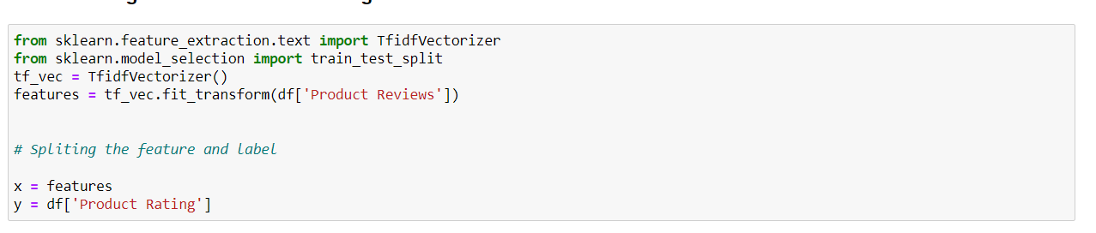

Best Random State for Random Forest Model:

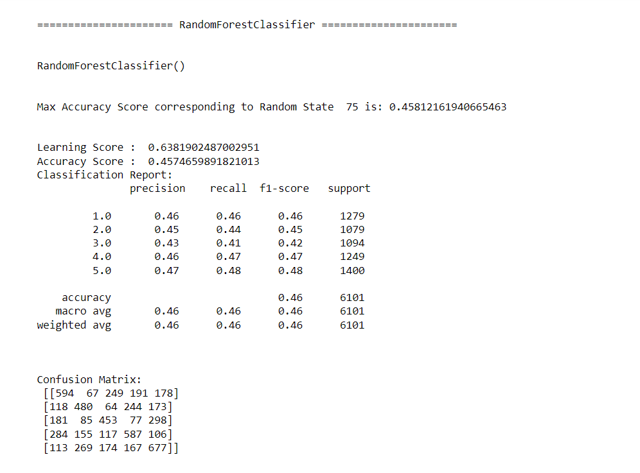

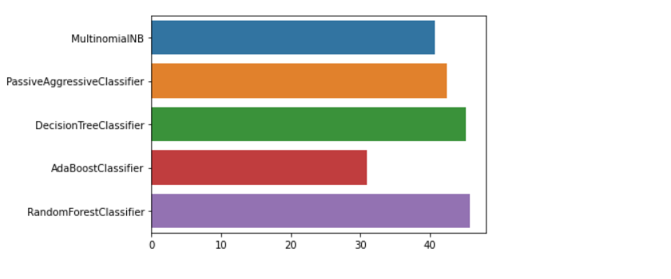

Above image shows the different accuracy scores of the different models.

**Analysing the accuracy of the models:**

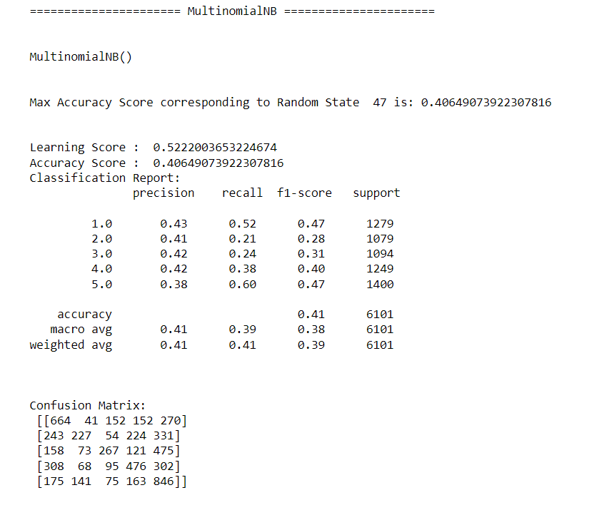

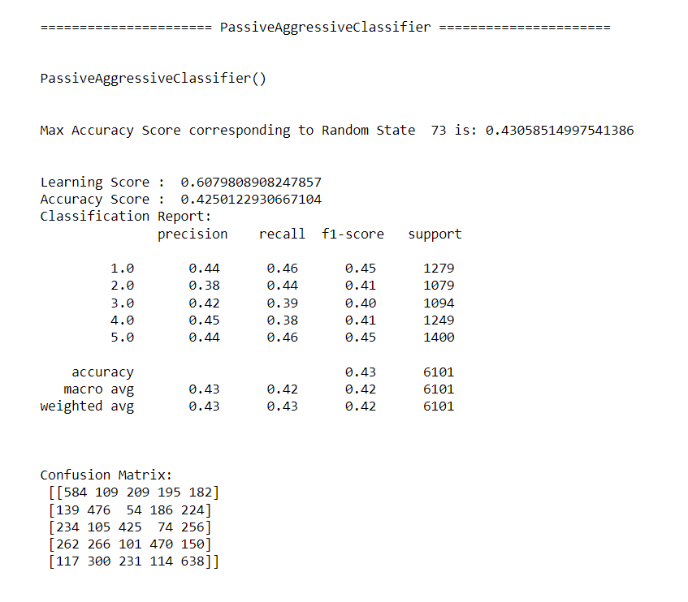

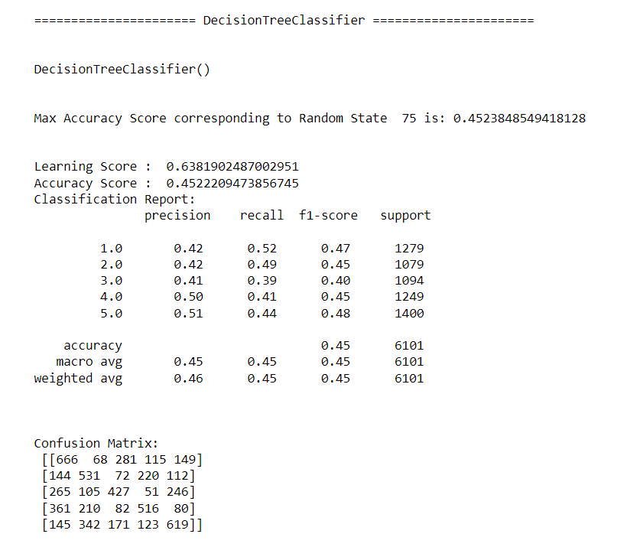

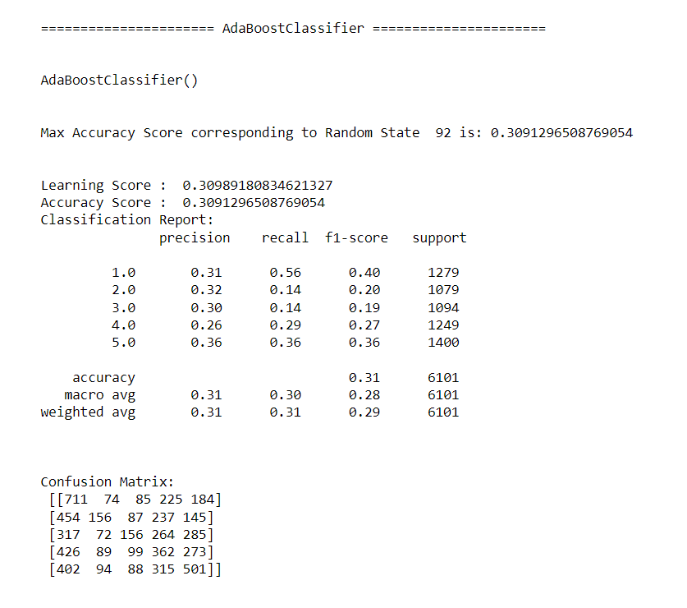

**Confusion metrix for the Random Forest Model:**

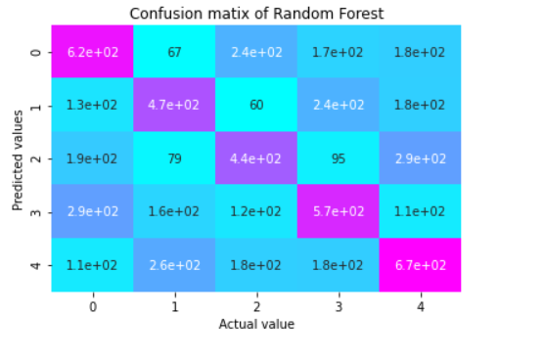

**Conclusion:**

The following image shows the Learning Score and the Accuracy Score of the different models.

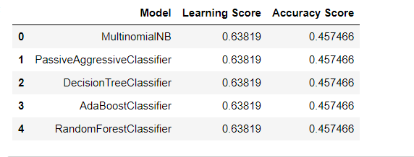

The following image shows the predicted values after training the model:

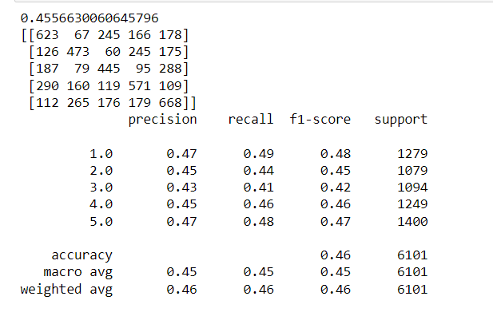

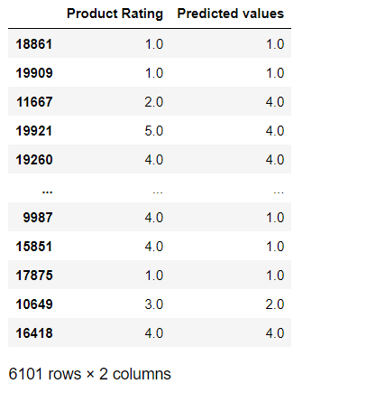

1. The various data pre-processing and feature engineering steps in the project lent cognizance to various efficient methods for processing textual data. The NLTK suite is very useful in pre-processing text-based data and building classification models.
2. Data cleaning was a very important step in removing null values from the dataset.
3. By training the models on more diverse data sets, longer comments, and a more balanced dataset, more accurate and efficient classification models can be built.

----- --:-- ----- ----- --:-- -----  ----- --:-- ---------- --:-- -----